**ST. XAVIER’S COLLEGE**

**Maitighar, Kathmandu**



DATABASE MANAGEMENT SYSTEM

theory Assignment #9

**Submitted by:**

Dibash Poudel

013BSCCSIT017

**Submitted to:**

Er. Sanjay Kr. Yadav

Lecturer, St. Xavier’s college

Department of Computer Science

**Date of Submission:**

October 1, 2015

**Database Recovery**

A major responsibility of the database administrator is to prepare for the possibility of hardware, software, network, process, or system failure. If such a failure affects the operation of a database system, you must usually recover the database and return to normal operation as quickly as possible. Recovery should protect the database and associated users from unnecessary problems and avoid or reduce the possibility of having to duplicate work manually.

Recovery processes vary depending on the type of failure that occurred, the structures affected, and the type of recovery that you perform. If no files are lost or damaged, recovery may amount to no more than restarting an instance. If data has been lost, recovery requires additional steps.

**Errors and Failures**

Several problems can halt the normal operation of an Oracle database or affect database I/O to disk. The following sections describe the most common types. For some of these problems, recovery is automatic and requires little or no action on the part of the database user or database administrator.

**User Error**

A database administrator can do little to prevent user errors (for example, accidentally dropping a table). Usually, user error can be reduced by increased training on database and application principles. Furthermore, by planning an effective recovery scheme ahead of time, the administrator can ease the work necessary to recover from many types of user errors.

**Statement Failure**

Statement failure occurs when there is a logical failure in the handling of a statement in an Oracle program. For example, assume all extents of a table (in other words, the number of extents specified in the MAXEXTENTS parameter of the CREATE TABLE statement) are allocated, and are completely filled with data; the table is absolutely full. A valid INSERT statement cannot insert a row because there is no space available. Therefore, if issued, the statement fails.

If a statement failure occurs, the Oracle software or operating system returns an error code or message. A statement failure usually requires no action or recovery steps; Oracle automatically corrects for statement failure by rolling back the effects (if any) of the statement and returning control to the application. The user can simply re-execute the statement after correcting the problem indicated by the error message.

**Process Failure**

A process failure is a failure in a user, server, or background process of a database instance (for example, an abnormal disconnect or process termination). When a process failure occurs, the failed subordinate process cannot continue work, although the other processes of the database instance can continue.

The Oracle background process PMON detects aborted Oracle processes. If the aborted process is a user or server process, PMON resolves the failure by rolling back the current transaction of the aborted process and releasing any resources that this process was using. Recovery of the failed user or server process is automatic. If the aborted process is a background process, the instance usually cannot continue to function correctly. Therefore, you must shut down and restart the instance.

**Network Failure**

When your system uses networks (for example, local area networks, phone lines, and so on) to connect client workstations to database servers, or to connect several database servers to form a distributed database system, network failures (such as aborted phone connections or network communication software failures) can interrupt the normal operation of a database system. For example:

* A network failure might interrupt normal execution of a client application and cause a process failure to occur. In this case, the Oracle background process PMON detects and resolves the aborted server process for the disconnected user process, as described in the previous section.
* A network failure might interrupt the two-phase commit of a distributed transaction. Once the network problem is corrected, the Oracle background process RECO of each involved database server automatically resolves any distributed transactions not yet resolved at all nodes of the distributed database system. Distributed database systems are discussed in [Chapter 33, "Distributed Databases"](http://www.csee.umbc.edu/portal/help/oracle8/server.815/a67781/c30dstdb.htm#8213).

**Database Instance Failure**

Database instance failure occurs when a problem arises that prevents an Oracle database instance (SGA and background processes) from continuing to work. An instance failure can result from a hardware problem, such as a power outage, or a software problem, such as an operating system crash. Instance failure also results when you issue a SHUTDOWN ABORT or STARTUP FORCE command.

#### Media (Disk) Failure

An error can arise when trying to write or read a file that is required to operate an Oracle database. This occurrence is called media failure because there is a physical problem reading or writing to files on the storage medium.

A common example of media failure is a disk head crash, which causes the loss of all files on a disk drive. All files associated with a database are vulnerable to a disk crash, including datafiles, online redo log files, and control files.

The appropriate recovery from a media failure depends on the files affected.

### 

## Rolling Forward and Rolling Back

Database buffers in the buffer cache in the SGA are written to disk only when necessary, using a least-recently-used algorithm. Because of the way that the DBWn process uses this algorithm to write database buffers to datafiles, datafiles might contain some data blocks modified by uncommitted transactions and some data blocks missing changes from committed transactions.

Two potential problems can result if an instance failure occurs:

* Data blocks modified by a transaction might not be written to the datafiles at commit time and might only appear in the redo log. Therefore, the redo log contains changes that must be reapplied to the database during recovery.
* After the roll forward phase, the datafiles may contain changes that had not been committed at the time of the failure. These uncommitted changes must be rolled back to ensure transactional consistency. These changes were either saved to the datafiles before the failure, or introduced during the roll forward phase.

To solve this dilemma, two separate steps are generally used by Oracle for a successful recovery of a system failure: rolling forward with the redo log (cache recovery) and rolling back with the rollback segments (transaction recovery).

### The Redo Log and Rolling Forward

The redo log is a set of operating system files that record all changes made to any database buffer, including data, index, and rollback segments, whether the changes are committed or uncommitted. Each redo entry is a group of change vectors describing a single atomic change to the database. The redo log protects changes made to database buffers in memory that have not been written to the datafiles.

The first step of recovery from an instance or disk failure is to roll forward, or reapply all of the changes recorded in the redo log to the datafiles. Because rollback data is also recorded in the redo log, rolling forward also regenerates the corresponding rollback segments. This is called cache recovery.

Rolling forward proceeds through as many redo log files as necessary to bring the database forward in time. Rolling forward usually includes online redo log files and may include archived redo log files.

After roll forward, the data blocks contain all committed changes. They may also contain uncommitted changes that were either saved to the datafiles before the failure, or were recorded in the redo log and introduced during roll forward.

### Rollback Segments and Rolling Back

Rollback segments record database actions that should be undone during certain database operations. In database recovery, rollback segments undo the effects of uncommitted transactions previously applied by the rolling forward phase.

After the roll forward, any changes that were not committed must be undone. After redo log files have reapplied all changes made to the database, then the corresponding rollback segments are used. Rollback segments are used to identify and undo transactions that were never committed, yet were either saved to the datafiles before the failure, or were applied to the database during the roll forward. This process is called rolling back or transaction recovery.

Figure illustrates rolling forward and rolling back, the two steps necessary to recover from any type of system failure.

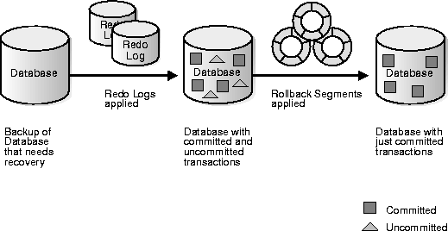

#### Figure Basic Recovery Steps: Rolling Forward and Rolling Back

[1]

**The Transaction Log:**

A DBMS uses a transaction log to keep track of all transactions that update the

database. The information stored in this log is used by the DBMS for a recovery

requirement triggered by a ROLLBACK statement, a program’s abnormal termination, or a system failure such as a network discrepancy or a disk crash. Some RDBMSs use the transaction log to recover a database forward to a currently consistent state. After a server failure, for example, Oracle automatically rolls back uncommitted transactions and rolls forward transactions that were committed but not yet written to the physical database.

While the DBMS executes transactions that modify the database, it also automatically updates the transaction log.

The transaction log stores:

* A record for the beginning of the transaction.
* For each transaction component (SQL statement):
* ➢ The type of operation being performed (update, delete, insert).
* ➢ The names of the objects affected by the transaction (the name of the table).
* ➢ The “before” and “after” values for the fields being updated.
* ➢ Pointers to the previous and next transaction log entries for the same transaction.
* The ending (COMMIT) of the transaction.[4]

**The Storage Hierarchy**

|  |  |
| --- | --- |
| Depending on the DBMS, a page is also called a [data block](http://codeidol.com/community/sql/the-storage-hierarchy/3437/app02.html#gloss53), a [block](http://codeidol.com/community/sql/the-storage-hierarchy/3437/app02.html#gloss19), a [blocking unit](http://codeidol.com/community/sql/the-storage-hierarchy/3437/app02.html#gloss21), a [control interval](http://codeidol.com/community/sql/the-storage-hierarchy/3437/app02.html#gloss48), and a [row group](http://codeidol.com/community/sql/the-storage-hierarchy/3437/app02.html#gloss197).  A page is a fixed-size hopper that stores rows of data. Pages have four common characteristics, which are not true by definition but are always true in practice. They are:   * All pages in a file have the same size. Indeed for some DBMSs, it is true that all pages in all files have the same size, but the usual case is that you have a choice when making a new object. * The choice of page sizes is restricted to certain multiples of 1024 (1KB), in a range between 1024 and 65536—that is, between 1KB and 64KB. * The optimum page size is related to the disk system's attributes. Smaller page sizes like 2KB were once the norm, but disks' capacity tends to increase over time, so now 8KB is reasonable, while 16KB is what we'll upgrade to soon. * Pages contain an integral number of rows. Even for the rare DBMSs that allow large rows to overflow into later pages, the very strong recommendation is that you should avoid overflow.[2] | asdasdasd.gif |

**Buffer Management**

We need to use disk storage for the database, and to transfer blocks of data between MM and disk.We also want to minimize the number of such transfers, as they are time-consuming.One way is to keep as many blocks as possible in MM.Usually, we cannot keep all blocks in MM, so we need to manage the allocation of available MM space.The **buffer** is the part of MM available for storage of **copies** of disk blocks.The subsystem responsible for the allocation of buffer space is called the **buffer manager**.The buffer manager handles all requests for blocks of the database.If the block is already in MM, the address in MM is given to the requestor.If not, the buffer manager must read the block in from disk (possibly displacing some other block if the buffer is full) and then pass the address in MM to the requestor.

The buffer manager must use some sophisticated techniques in order to provide good service:

* + **Replacement Strategy** - When there is no room left in the buffer, some block must be removed to make way for the new one. Typical operating system memory management schemes use a ``least recently used'' (**LRU**) method. (Simply remove the block least recently referenced.) This can be improved upon for database applications.
  + **Pinned Blocks** - For the database to be able to recover from crashes, we need to restrict times when a block maybe written back to disk. A block not allowed to be written is said to be **pinned**. Many operating systems do not provide support for pinned blocks, and such a feature is essential if a database is to be ``crash resistant''.
  + **Forced Output of Blocks** - Sometimes it is necessary to write a block back to disk even though its buffer space is not needed. (Called the **forced output** of a block.) This is due to the fact that MM contents (and thus the buffer) are lost in a crash, while disk data usually survives.

**Replacement Strategy:** Goal is minimization of accesses to disk. Generally it is hard to predict which blocks will be referenced. So operating systems use the history of past references as a guide to prediction.

* + **General Assumption:** Blocks referenced recently are likely to be used again.
  + **Therefore:** if we need space, throw out the least recently referenced block. (LRU replacement scheme)

LRU is acceptable in **operating systems**, however, a database system is able to predict future references more accurately.

Assume that the two relations in this example are stored in different files.

* + Once a tuple of *borrow* has been processed it is not needed again.
  + Therefore, once processing of an entire block of tuples is finished, that block is not needed in MM.
  + Note that this block has been used **very** recently.
  + Buffer manager should free the space occupied by a borrow block as soon as it is processed.
  + This strategy is called **toss-immediate**.
  + Consider blocks containing *customer* tuples.
  + Every block of *customer* tuples must be examined once for every tuple of the *borrow* relation.
  + When processing of a *customer* block is completed, it will not be used again until all other *customer* blocks have been processed.
  + This means the most recently used (MRU) block will be the last block to be re-referenced, and the least recently used will be referenced next.
  + This is the opposite of LRU assumptions.
  + So for inner block, use MRU strategy - if a customer block must be removed from the buffer, choose MRU block.
  + For MRU strategy, the system must **pin** the *customer* block currently being processed until the last tuple has been processed.
  + Then it may be unpinned, becoming the most recently used block.

1. The buffer manager may also use statistical information regarding the probability that a request will reference a particular relation.
   * The data dictionary is the most frequently-used part of the database.
   * It should, therefore, not be removed from MM unless necessary.
   * File indices (Chapter 8) are also frequently used, and should generally be in MM.
   * No single strategy is known that handles all possible scenarios well.
   * Many database systems use LRU, with all its faults.
   * Other factors enter with concurrent users, where requests may be delayed to ensure integrity of the database.[3]

## Shadow Paging

It is inconvienient to maintain logs of all transactions fro the purposes of recovery. An alternative is to use a system of shadow paging. This is where the database is divided into pages that may be stored in any order on the disk. In order to identify the location of any given page, we use something called a page table. See the diagram below:  
*Get image from back of handout with page tables* *Diagram.*

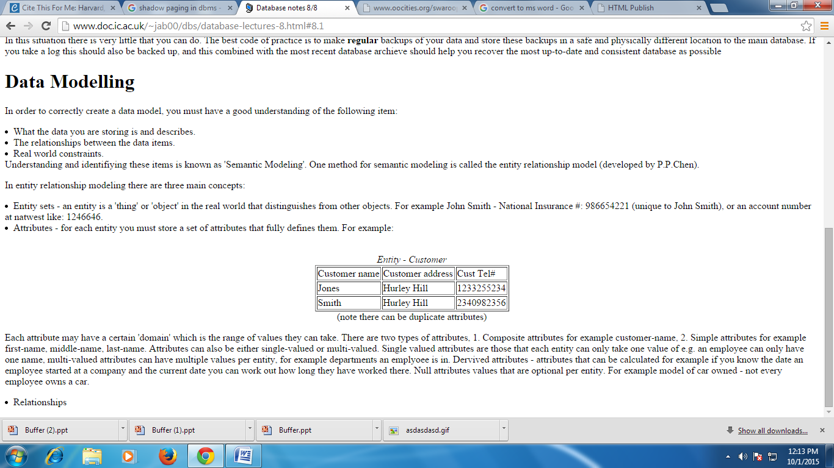

During the life of a transaction two page tables are maintained, one called a shadow page table and current page table. When a transactions begins both of these page tables point to the same locations (are identical). During the lifetime of a transaction the shadow page table doesn't change at all. However during the lifetime of a transaction changes may be made update values etc. So whenever we update a page in the database we always write the updated page to a new location. This means that when we then update our current page table to reflect the changes that have been made.

Looking at diagram we see how these tables appear during a transaction. As we can see the shadow page table shows the state of the database just prior to a transaction, and the current page table shows the state of the database during or after a transaction has been completed.

We now have a system whereby if we ever want to undo the actions of a transaction all we have to do is to do is recover the shadow page table to be the current page table. As such this makes the shadow page table particularly important, and so it must always be stored on stable storage. On disk we store a single pointer location that points to the address of the shadow page table. This means that to swept the shadow table for the current page table (committing the data) we just need to update this single pointer (very unlikely to fail during this very short fast operation).[5]

**Check pointing**

Checkpoint-Recovery is a common technique for imbuing a program or system with fault tolerant qualities, and grew from the ideas used in systems which employ transaction processing. It allows systems to recover after some fault interrupts the system, and causes the task to fail, or be aborted in some way. While many systems employ the technique to minimize lost processing time, it can be used more r from faults in a critical application or task.

The basic idea behind checkpoint-recover is the saving and restoration of system state. By saving the current state of the system periodically or before critical code sections, it provides the baseline information needed for the restoration of lost state in the event of a system failure. While the cost of checkpoint-recovery can be high, by using techniques like memory exclusion, and by designing a system to have as small a critical state as possible may minimize the cost of checkpointing enough to be useful in even cost sensitive embedded applications.[6]

broadly to tolerate and recove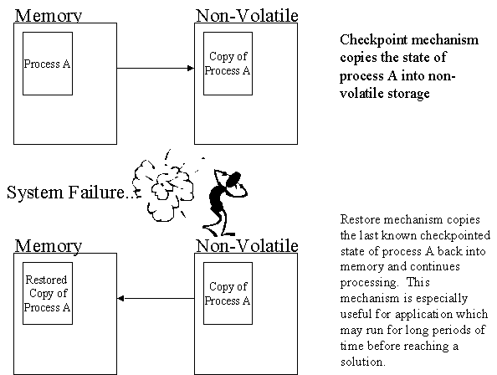

|  |
| --- |
|  |

# Write-Ahead Logging (WAL)

*Write-Ahead Logging* (WAL) is a standard method for ensuring data integrity. A detailed description can be found in most (if not all) books about transaction processing. Briefly, WAL's central concept is that changes to data files (where tables and indexes reside) must be written only after those changes have been logged, that is, after log records describing the changes have been flushed to permanent storage. If we follow this procedure, we do not need to flush data pages to disk on every transaction commit, because we know that in the event of a crash we will be able to recover the database using the log: any changes that have not been applied to the data pages can be redone from the log records. (This is roll-forward recovery, also known as REDO.)

Using WAL results in a significantly reduced number of disk writes, because only the log file needs to be flushed to disk to guarantee that a transaction is committed, rather than every data file changed by the transaction. The log file is written sequentially, and so the cost of syncing the log is much less than the cost of flushing the data pages. This is especially true for servers handling many small transactions touching different parts of the data store. Furthermore, when the server is processing many small concurrent transactions, one fsync of the log file may suffice to commit many transactions.

By archiving the WAL data we can support reverting to any time instant covered by the available WAL data: we simply install a prior physical backup of the database, and replay the WAL log just as far as the desired time. What's more, the physical backup doesn't have to be an instantaneous snapshot of the database state — if it is made over some period of time, then replaying the WAL log for that period will fix any internal inconsistencies.[7]

**RECOVERY IN MULTIDATABASE SYSTEMS**

To maintain the atomicity of a multi database transaction, it is necessary to have a two-level recovery mechanism. A global recovery manager, or coordinator, is needed to maintain information needed for recovery, in addition to the local recovery managers and the information they maintain (log, tables).

## The coordinator usually follows a protocol called the two-phase commit protocol, whose two phases can be stated as follows:

## • Phase 1: When all participating databases signal the coordinator that the part of the multidatabase transaction involving each has concluded, the coordinator sends a message "prepare for commit" to each participant to get ready for committing the transaction. Each participating database receiving that message will force-write all log records and needed information for local recovery to disk and then send a "ready to commit" or "OK" signal to the coordinator. If the force-writing to disk fails or the local transaction cannot commit for some reason, the participating database sends a "cannot commit" or "not OK" signal to the coordinator. If the coordinator does not receive a reply from a database within a certain time out interval, it assumes a "not OK" response.

## • Phase 2: If all participating databases reply "OK," and the coordinator’s vote is also "OK," the transaction is successful, and the coordinator sends a "commit" signal for the transaction to the participating databases. Because all the local effects of the transaction and information needed for local recovery have been recorded in the logs of the participating databases, recovery from failure is now possible. Each participating database completes transaction commit by writing a [commit] entry for the transaction in the log and permanently updating the database if needed. On the other hand, if one or more of the participating databases or the coordinator have a "not OK" response, the transaction has failed, and the coordinator sends a message to "roll back" or UNDO the local effect of the transaction to each participating database. This is done by undoing the transaction operations, using the log.

## The net effect of the two-phase commit protocol is that either all participating databases commit the effect of the transaction or none of them do. In case any of the participants—or the coordinator—fails, it is always possible to recover to a state where either the transaction is committed or it is rolled back. A failure during or before Phase 1 usually requires the transaction to be rolled back, whereas a failure during Phase 2 means that a successful transaction can recover and commit.

## Data updates

Immediate Update: As soon as a data item is modified in cache, the disk copy is updated.

Deferred Update: All modified data items in the cache is written either after a transaction ends its execution or after a fixed number of transactions have completed their execution.

Shadow update: The modified version of a data item does not overwrite its disk copy but is written at a separate disk location.

In-place update: The disk version of the data item is overwritten by the cache version.

**Data caching**

The Database Management System (DBMS) is a memory buffer which stores copies of portions of the database that the DBMS is currently using. Reading from memory is much faster than reading from the disk. The DBMS therefore returns a record more quickly if it is already stored in cache. As long as the required data is stored in cache, the data is immediately available. When the required data is not stored in cache, it must be copied from the disk and then stored in cache.

**Failure with Loss of No volatile Storage (General Concepts)**

A volatile storage like RAM stores all the active logs, disk buffers, and related data. In addition, it stores all the transactions that are being currently executed. What happens if such a volatile storage crashes abruptly? It would obviously take away all the logs and active copies of the database. It makes recovery almost impossible, as everything that is required to recover the data is lost.

Following techniques may be adopted in case of loss of volatile storage −

• We can have checkpoints at multiple stages so as to save the contents of the database periodically.

• A state of active database in the volatile memory can be periodicallydumped onto a stable storage, which may also contain logs and active transactions and buffer blocks.

• <dump> can be marked on a log file, whenever the database contents are dumped from a non-volatile memory to a stable one.

## References

## [1]<http://www.csee.umbc.edu/portal/help/oracle8/server.815/a67781/c28recov.htm#3829>

[2] <http://codeidol.com/community/sql/the-storage-hierarchy/3437/>

[3] <http://www.cs.sfu.ca/CourseCentral/354/zaiane/material/notes/Chap7/node11.html>

[4] <http://www.myreadingroom.co.in/images/stories/docs/dbms/the%20transaction%20log.pdf>

[5] <http://www.doc.ic.ac.uk/~jab00/dbs/database-lectures-8.html#8.1>

[6] <http://users.ece.cmu.edu/~koopman/des_s99/checkpoint/>

[7] <http://www.postgresql.org/docs/9.1/static/wal-intro.html>

[9] Fundamentals of Database Systems by Elmasri Navathe

## 